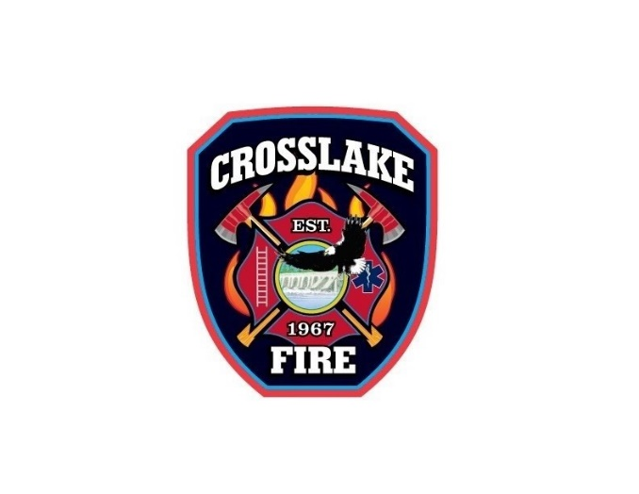 | 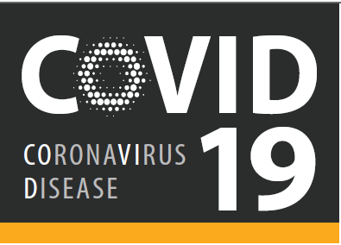

Pandemic Covid-19 Employee Procedure: 3/14/2020

Any Crosslake Fire Fighters with any of the following symptoms should NOT respond to calls!
- Fever
- Any sign of respiratory illness
- Cough*
- Shortness of breath
As stated before, for your own illness, you should not return to work until you have been fever-free for 72 hours or 7 days after the illness began – whichever is greater.
*If your cough is related to an already identified medical issue that is not contagious and has not changed, there is no need to stay home. For example, tree pollen counts are starting to ramp up and some people may by experiencing a scratchy throat, cough, itchy eyes and sneezing. With no other signs of illness, employees do not need to stay home.
WHAT SHOULD I DO NEXT?
6 step process:
- Immediately inform Chief Officer that you have symptoms.
- Complete the Illness Report (attached).
- Email completed report to Chief Lohmiller – chief1@crosslake.net .
- Contact Char at City Hall: 218-692-2688 – cityclerk@crosslake.net during regular business hours.
- You will be asked to provide City with your specific medical symptoms.
- The City will work with the MN Dept. of Health and they will contact you for an initial medical screening and if required, arrange for COVID-19 testing.

