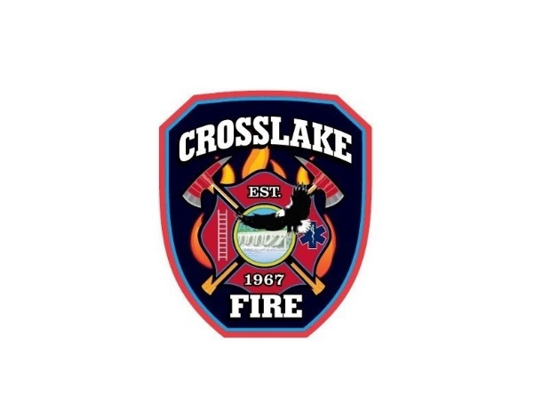 | ILLNESS REPORT FORM  Pandemic Coronavirus Response

Name: ____________________________________________ FF Badge Number #____________________
Please print

Symptoms include: (check all that apply):
Fever of ______________
Any sign of respiratory illness
Cough
Sore throat
Shortness of breath

What was first symptom? __________________________
When did it first appear? __________________________

As previously stated, for your own illness, you should not return to duty until you have been fever-free for 72 hours or 7 days after your symptoms began – whichever is greater.

You will require a further medical screening from the MN Dept of Health. Provide the phone number where you can be reached: ______________________________________
The MN Dept. of Health will determine if you should be screened for Covid-19 and make the arrangements for testing.

_______________________________________________ ____________________________
Employee Signature Date:

Safety Officer Received

Log Case #____________ ____________________________________ _______________
Chief Officer Signature Date

_____________________________________ _______________
City Clerk Signature Date

