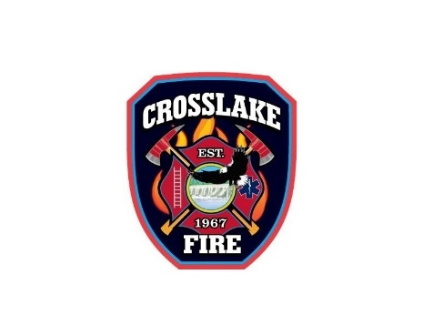
Fire Station Proactive Measures
COVID-19 Pandemic Response
Purpose:
- Proactively prevent the possible spread of the virus within our organization.
- Maintain, reduce exposure risk, and protect the Crosslake Fire Department, so that we can continue to protect and serve the public.
- Protect the Fire Station from contamination and possible subsequent quarantine.
- Protect vulnerable and high-risk population within our community and response area.

Actions:
- Restrict access of all visitors, to include citizens and family members. Post signage on entry doors.
- Restrict access to Fire Station for anyone (Membership and Citizens) showing signs of fever or respiratory illness.
- Limit points of entry to Fire Station to single entry point.
- Perform hand hygiene with alcohol-based cleaner upon entry to Fire Station.
- Institute voluntary proactive self-assessment and monitoring of all membership and employees of the City of Crosslake.
  - Complete temperature monitoring
  - Complete self-assessment questionnaire
- Complete station / Apparatus cleaning and decontamination after each incident.

Employee Self-Assessment and Monitoring
Questions:
- Do you have a fever (Defined as >100.4)?
- Do you have any signs of respiratory illness?
- Do you have a cough?
- Do you have shortness of breath?
If YES to any of the above, immediately notify the Chief and or City Clerk.
Complete the Employee Illness Report Form
Complete the Employee Duty Related Exposure Form
If NO, it is encouraged to perform self-assessment and temperature monitoring each day.

